Sync API Architecture
and Implementation Changes
Agentic Orchestration + Agent Executor
Architecture overview, change summary, operational controls, and current known limitations
━━━━━━━━━━━━━━━━━━━━━━━━━━━━━━━━━━━━━━━━
Prepared from the Copilot-generated implementation report provided in this conversation
Updated presentation version — 13 Aug 2026
Source basis
This document restructures and clarifies the implementation facts visible in the supplied Copilot report screenshots. It is not an independent repository/code audit; where the report identifies a limitation or discrepancy, that finding is preserved rather than silently corrected.

Document Guide
This version is designed to be easier to present than the raw Copilot report. It separates architecture, implementation changes, runtime controls, and remaining operational concerns so a reader can understand the platform first and then drill into details.
Section | Purpose
1. Executive overview | What changed and the core design principle
2. Previous architecture | How the Kafka-only async flow worked
3. Current architecture | How sync and async now coexist
4. Sync APIs | The four public synchronous entry points
5–7. Implementation changes | Orchestration, Executor, and shared runtime
8–11. Runtime behavior | Multi-step loop, DB state, capacity, HTTP communication
12–15. Production controls | Security, timeouts, drain, observability
16. Deployment/config | Helm/OpenShift configuration
17. Known limitations | Items explicitly identified by the Copilot report
18. Presentation summary | A concise team explanation and readiness checklist

Core design principle
Sync and async are two transport/orchestration modes over the same agent execution engine. The sync path bypasses Kafka between Orchestration and Executor, but it does not create a second agent runtime.

1. Executive Overview
The platform originally supported only asynchronous Kafka-driven task execution. The caller submitted work, received an immediate acknowledgement, and later received the final answer through a Kafka response topic or webhook. The completed implementation adds a synchronous, blocking mode across four public API variants while preserving the existing async APIs.
Area | Before | Current
Caller experience | Immediate acknowledgement; final result later | Choice of existing async flow or blocking sync flow
Orchestration role | Plan and publish work to Kafka | Still plans; additionally owns the sync execution loop
Executor entry point | Kafka consumer | Kafka consumer + protected internal HTTP step API
Execution engine | AgentExecutionService / ADK / tools | Same shared runtime for both modes
Step-to-step transport | Kafka | Kafka for async; direct HTTP for sync
Final delivery | Kafka topic / webhook | Async unchanged; sync returns final HTTP response
Capacity control | Async execution only | Independent async and sync semaphores in Executor

What did not change
AgentExecutionService, AgentFactory, ADK Runner, DbLoggerPlugin and the shared PostgreSQL stores remain common; no separate sync agent runtime was created.

2. Previous Architecture — Async Only
All task-execution variants used the same pattern: Orchestration authenticated and planned the request, published AGENT_EXECUTION_REQUEST to Kafka, and immediately returned HTTP 200 with a correlation identifier. Executor consumed the message independently. If more steps remained, the next hop was republished to Kafka. Final response assembly and delivery happened later and out of band.
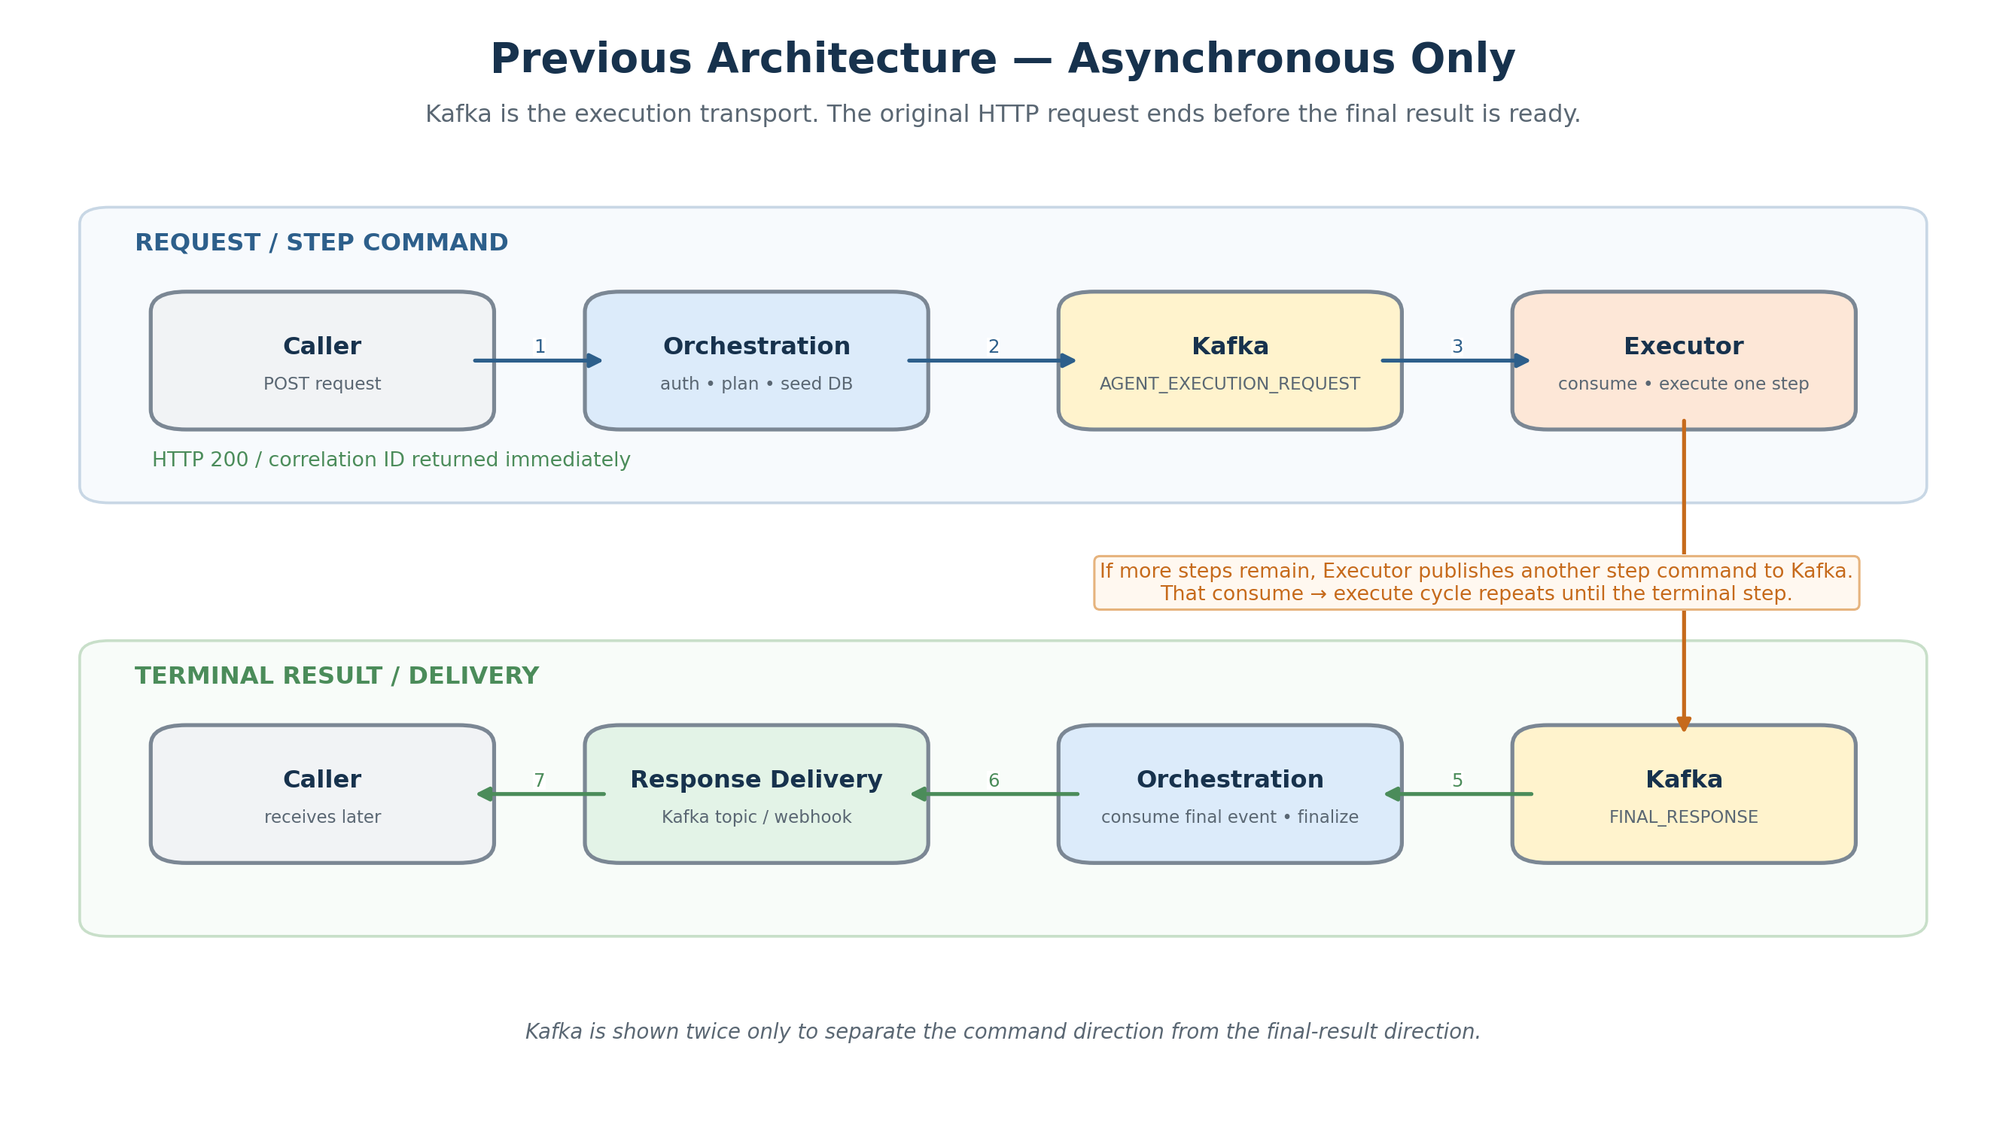
Figure 1 — Previous asynchronous architecture: Kafka mediates every execution hop.
- Caller does not hold the original HTTP connection open for the final answer.
- Kafka is the durable transport for each agent hop.
- Executor participates in step chaining by publishing the next execution request or final-response event.
- Orchestration finalizes the terminal response and ResponseService delivers it through Kafka or webhook.

3. Current Architecture — Sync and Async Side by Side
The current design supports synchronous HTTP execution and the existing asynchronous Kafka path side by side. This architecture view separates responsibilities instead of trying to show every request/return arrow. The detailed synchronous execution sequence is shown later in Section 5.
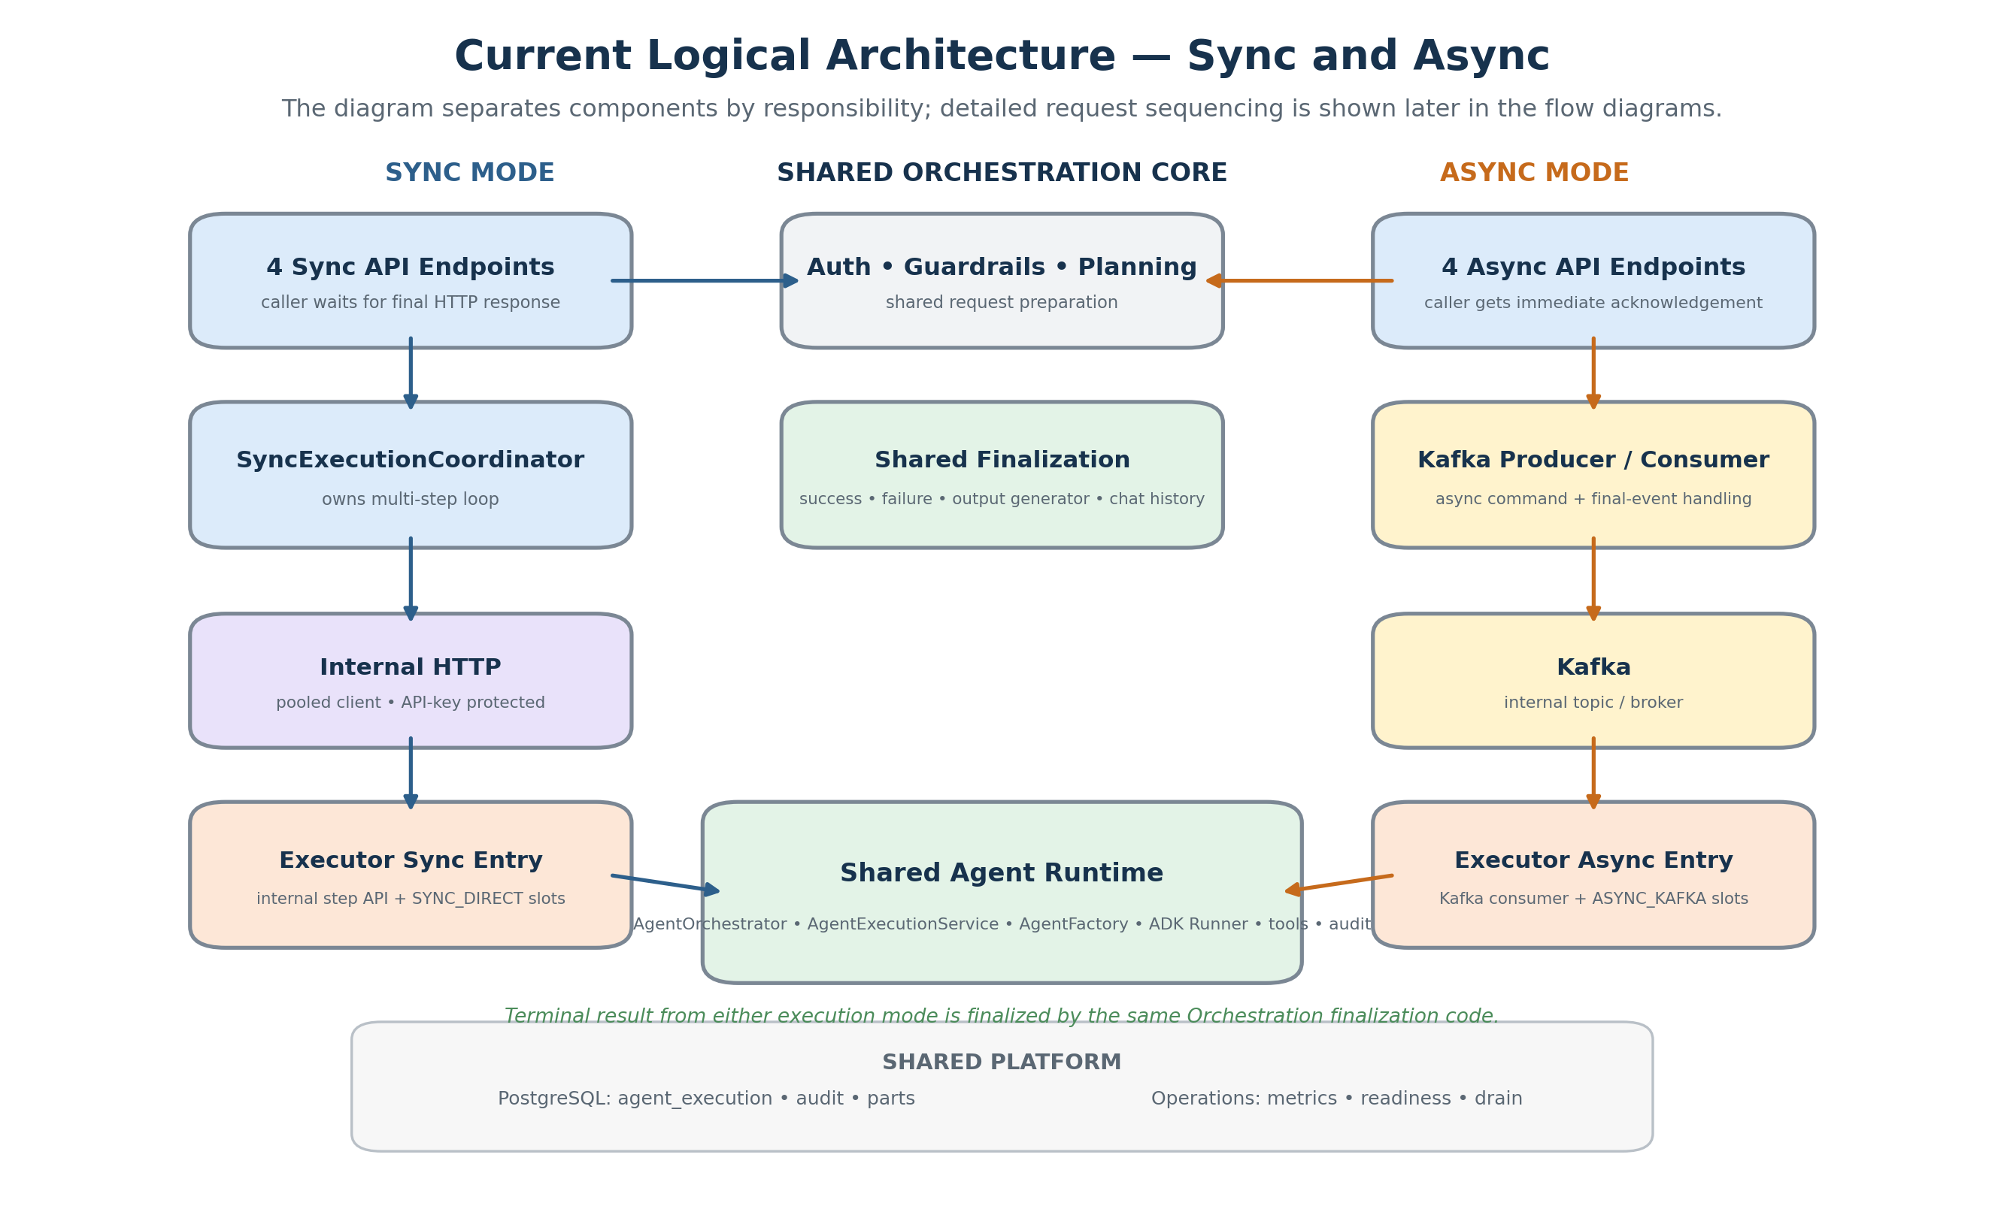
Figure 2 — Current logical component architecture: sync and async use separate transports and capacity entry points, while sharing planning, finalization, agent runtime, and platform services.

3.1 Cloud-Native Multi-Pod Deployment View
At deployment level, Orchestration and Executor are independent Kubernetes/OpenShift deployments. Synchronous traffic crosses the cluster through the Executor internal HTTP service; asynchronous traffic uses Kafka. Both deployments can scale horizontally and use the same PostgreSQL and operational platform services.
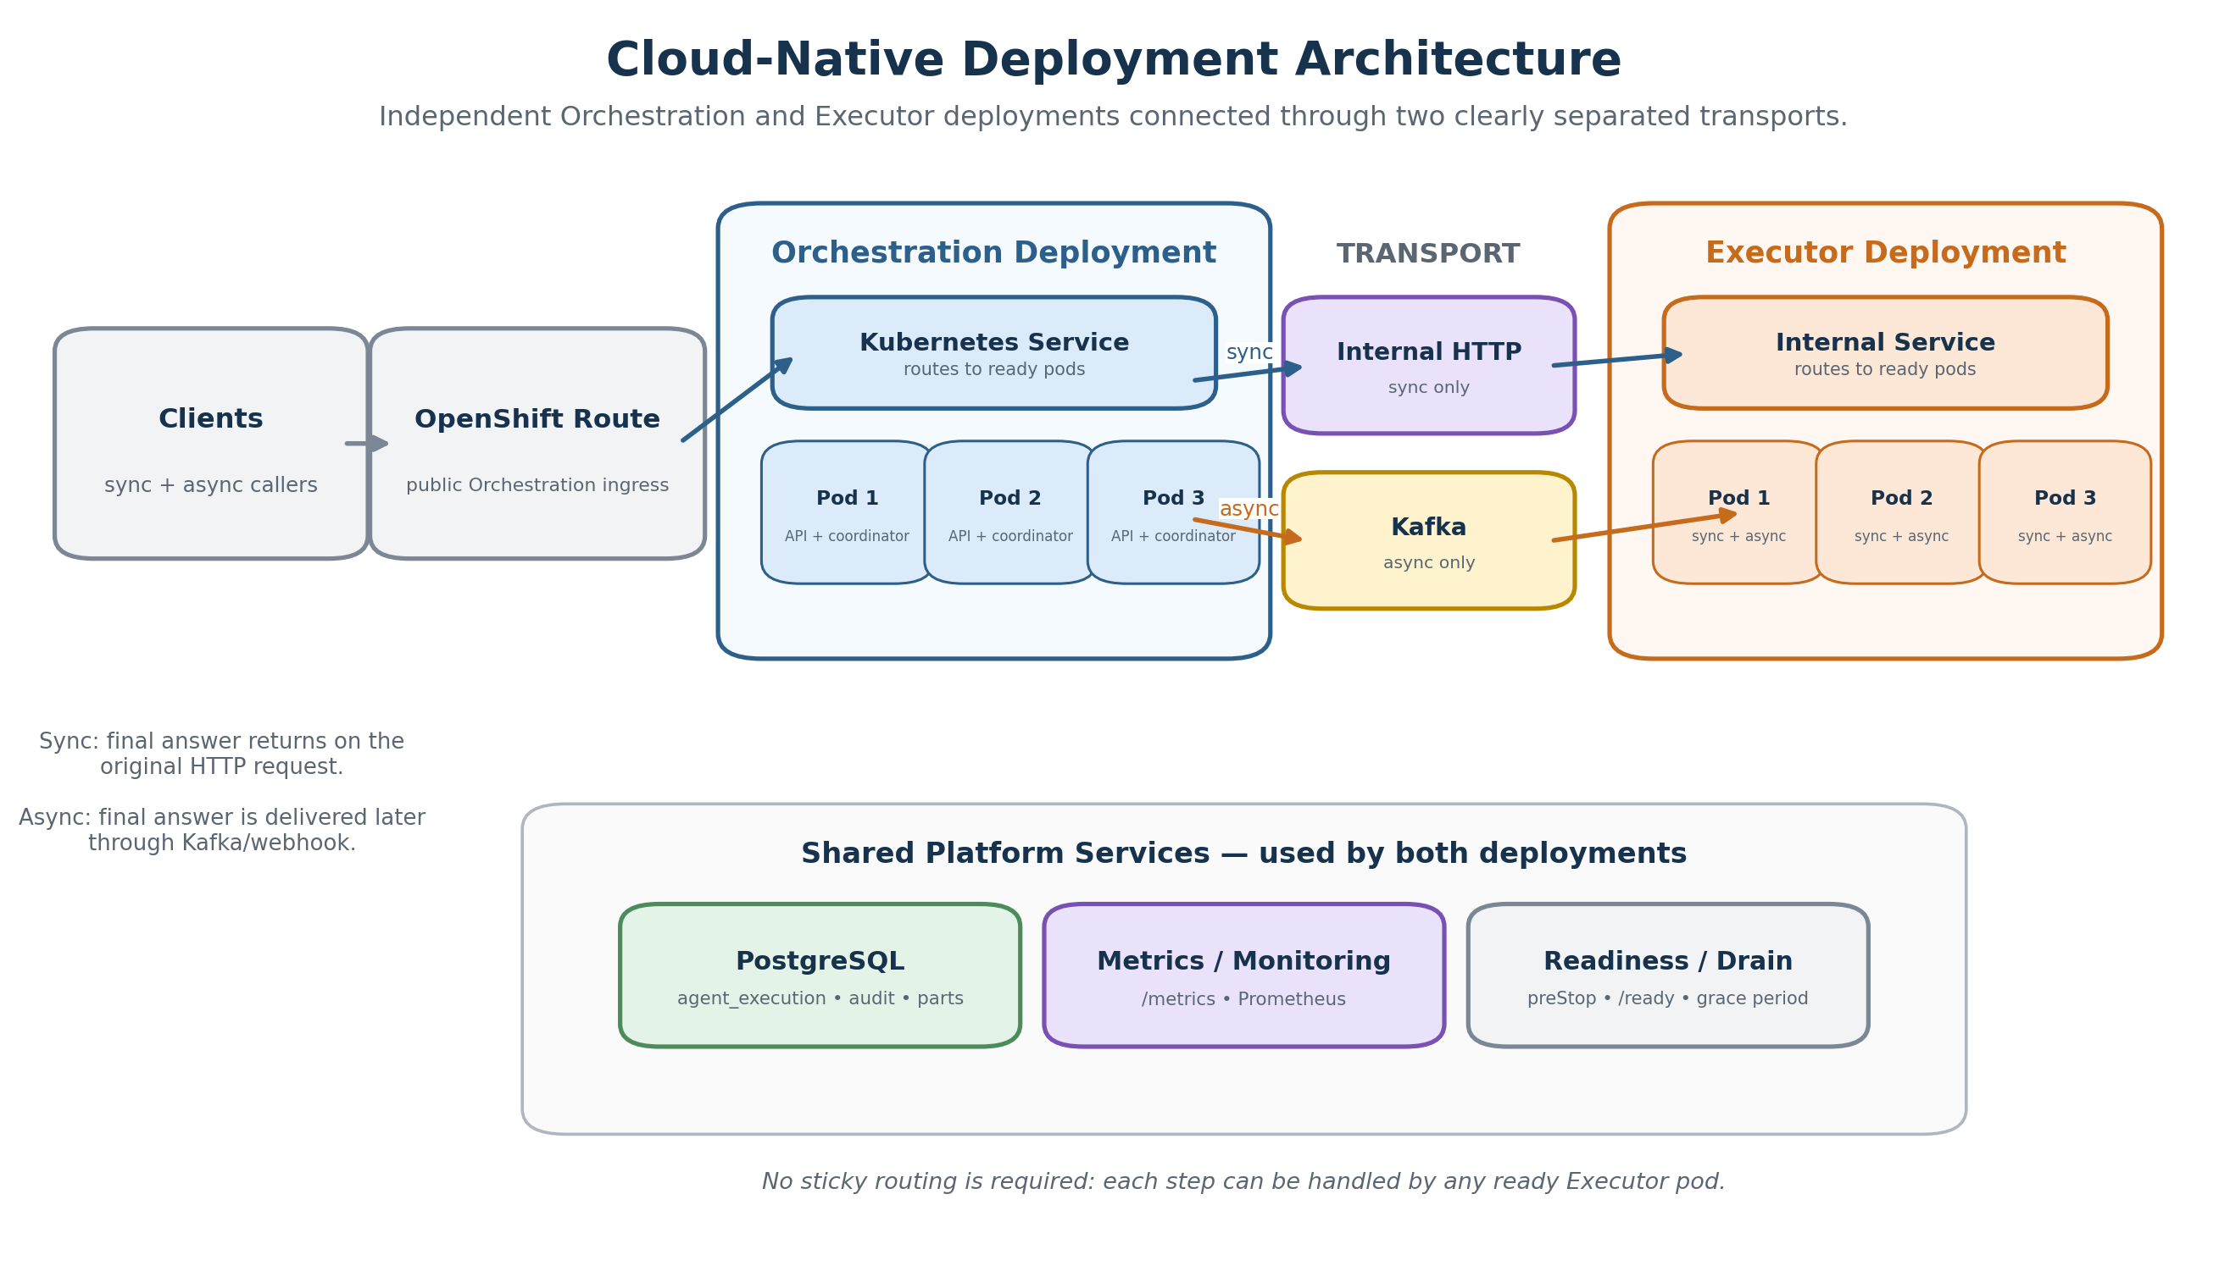
Figure 3 — Cloud-native deployment architecture: separate pod groups, separate sync/async transports, and shared platform services without sticky routing.
Architecture takeaway: Orchestration and Executor scale independently. New synchronous work is routed only to ready pods, while Kafka and PostgreSQL remain shared platform services across all replicas.
Key architecture boundary
Orchestration owns the synchronous workflow loop. Executor executes one already-planned step per sync HTTP call. In ASYNC_KAFKA mode, the existing Kafka publication/consumption behavior is preserved.

4. Public Sync APIs Implemented
The Copilot report identifies four synchronous endpoints in orchestration/api/api.py. They mirror the existing async API families and share a common private helper before delegating to SyncExecutionCoordinator.
Endpoint | Request model / purpose
/api/v1/agentic-orchestration/task-executor/sync | TaskRequest — baseline single/multi-step synchronous execution
/api/v1/agentic-orchestration/conversational-task-executor/sync | ConversationalTaskRequest — includes chat-history behavior in finalization
/api/v1/agentic-orchestration/native-conversational-task-executor/sync | NativeConversationalTaskRequest — DB-persisted ADK session; requires Session-ID
/api/v1/agentic-orchestration/agent-testing/sync | TaskRequest — force-static mode; optional test-agent header to target one agent

- All four public sync endpoints use the standard COIN JWT authentication described in the report.
- The sync path is feature-flagged and is off by default in the deployed environment values shown in the report.
- The caller’s HTTP connection remains open until final response, timeout, disconnect, or another terminal failure.

5. Synchronous Execution Flow
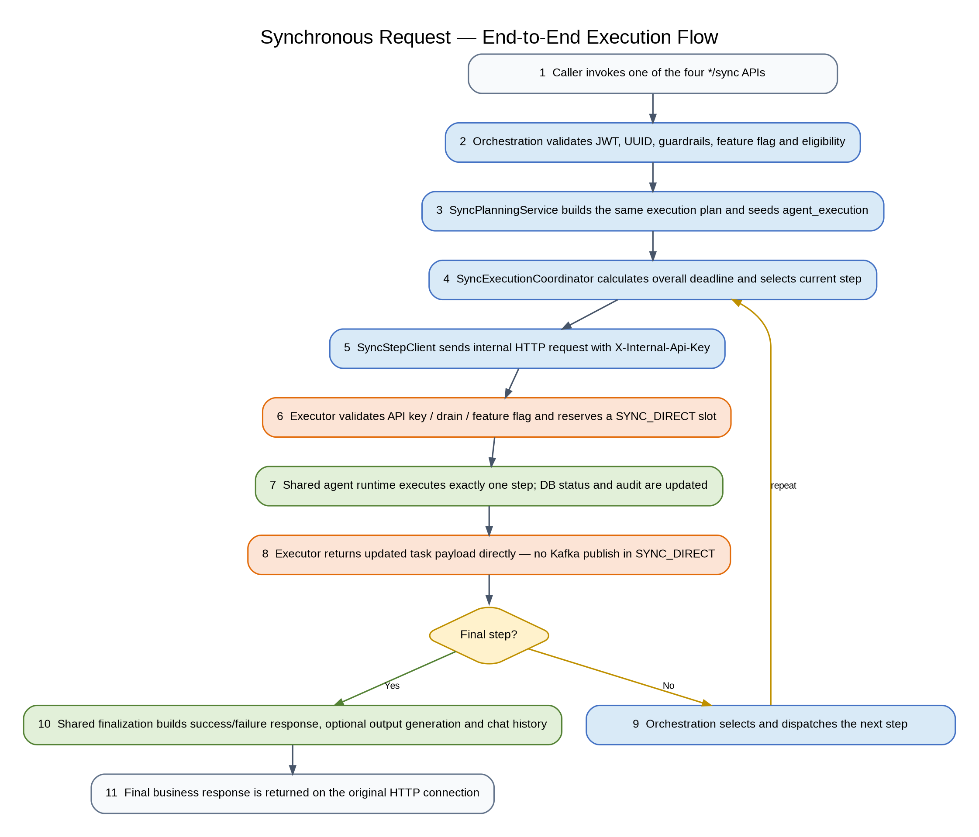
Figure 4 — Numbered synchronous execution flow.

5.1 What happens in simple terms
- Orchestration performs the same front-door validation and planning responsibilities used by the async APIs.
- SyncPlanningService builds the task payload and execution plan without publishing the first step to Kafka.
- SyncExecutionCoordinator owns the loop and calculates the overall deadline once.
- For each step, SyncStepClient sends one internal HTTP POST to Executor with an internal API key and a per-step timeout.
- Executor executes exactly one step in SYNC_DIRECT mode and returns the updated payload directly.
- Orchestration merges the result, selects the next step, and repeats until the payload indicates a final response.
- The shared finalization service produces the same business-level success/failure response shape used by async processing, then FastAPI returns it to the caller.

6. What Changed in Orchestration
Area / file | Change
orchestration/service/sync_execution_coordinator.py | New sync coordinator that owns multi-step loop, deadline checks, disconnect race and terminal finalization.
orchestration/service/sync_step_client.py | New shared/lazy aiohttp client with pooled connections for internal Executor calls.
orchestration/service/sync_planning_service.py | Builds sync task payload and plan inline; avoids Kafka publication for sync initiation.
orchestration/api/api.py | Adds four */sync routes and shared sync request handling.
orchestration/service/finalization_service.py | Shared business finalization used by both sync and async paths.
orchestration/util/drain_state.py + util/metrics.py | Adds drain flag and Prometheus metric definitions/helpers.
orchestration/config/environment.py + Helm | Adds sync enablement, Executor URL, timeout, connection-pool and API-key configuration.

Important discrepancy preserved from the Copilot report
Earlier design material apparently described Orchestration writing per-step execution status for sync. The current implementation report says SyncExecutionCoordinator performs no per-step DB status writes; Executor performs those transitions for both modes.

7. What Changed in Executor
Area / file | Change
executor/api/api.py | Adds protected POST /internal/v1/agent-step; hidden from Swagger; validates X-Internal-Api-Key and executes one sync step.
executor/api/api.py — parts helper | Adds sync re-attachment path for offloaded multimodal parts to preserve parity with async behavior.
executor/models/execution_mode.py | Adds ExecutionMode values SYNC_DIRECT and ASYNC_KAFKA.
executor/service/execution_capacity.py | Adds two independent asyncio.Semaphore pools for sync and async capacity.
executor/service/agent_orchestrator.py | Branches transport behavior by execution_mode: sync returns payload directly; async Kafka behavior remains.
executor/util/metrics.py + util/drain_state.py | Adds Prometheus metrics and drain state.
executor/config/environment.py + Helm | Adds internal API key, sync endpoint enablement and concurrency controls.

Shared core
The report states that AgentExecutionService, AgentFactory, ADK Runner, DbLoggerPlugin and the DB stores were not split into separate sync implementations. This is the central code-reuse decision.

8. Shared Runtime and Finalization
The implementation treats sync and async as two entry/transport modes into a common execution engine. The differences are concentrated at the edges: how work arrives, who drives the next-step loop, and how the final result is delivered.
Capability | Shared | Sync-specific | Async-specific
Planning/data structures | Execution plan, TaskPayloadModel, agent_execution seed | SyncPlanningService avoids initial Kafka publish | Existing Kafka initiation path
Agent execution | AgentOrchestrator, AgentExecutionService, AgentFactory, ADK Runner, tools, sessions, audit | SYNC_DIRECT mode returns payload to HTTP caller | ASYNC_KAFKA publishes next/final Kafka events
Final business response | finalize(), output generator, error/state/chat-history logic | Returned by FastAPI | Passed to ResponseService
Transport | — | Pooled internal HTTP | Kafka publish/consume

8.1 Final-response rules identified in the report
- Any failed step produces a FAILED business response with canonical error information.
- Multi-step with output_generator_enabled=True calls prepare_response() to synthesize a final answer from agent outputs.
- Multi-step without an output generator uses the last step output.
- Single-step uses that step output (with the existing fallback behavior if empty).
- Conversational requests additionally apply chat-history preparation/finalization.

9. agent_execution State Flow
The report describes one agent_execution row per step/task. Initial rows are created by Orchestration; subsequent step-state transitions are written by Executor for both sync and async execution.
Lifecycle point | Writer | Write behavior from report
Plan created — initial status | Orchestration: add_agent_status() | Batched insert / single commit
Step begins — IN_PROGRESS | Executor: AgentOrchestrator execution path | Fire-and-forget asyncio task
Step succeeds — COMPLETED | Executor: response preparation path | Fire-and-forget asyncio task
Step fails — FAILED | Executor: error path | Awaited; not fire-and-forget

Persistence interpretation
agent_execution is step-status/state metadata, not a durable assembled final-result store. The report also indicates different consistency characteristics: FAILED is awaited while IN_PROGRESS/COMPLETED may lag because they are background writes.

10. Sync / Async Capacity Isolation
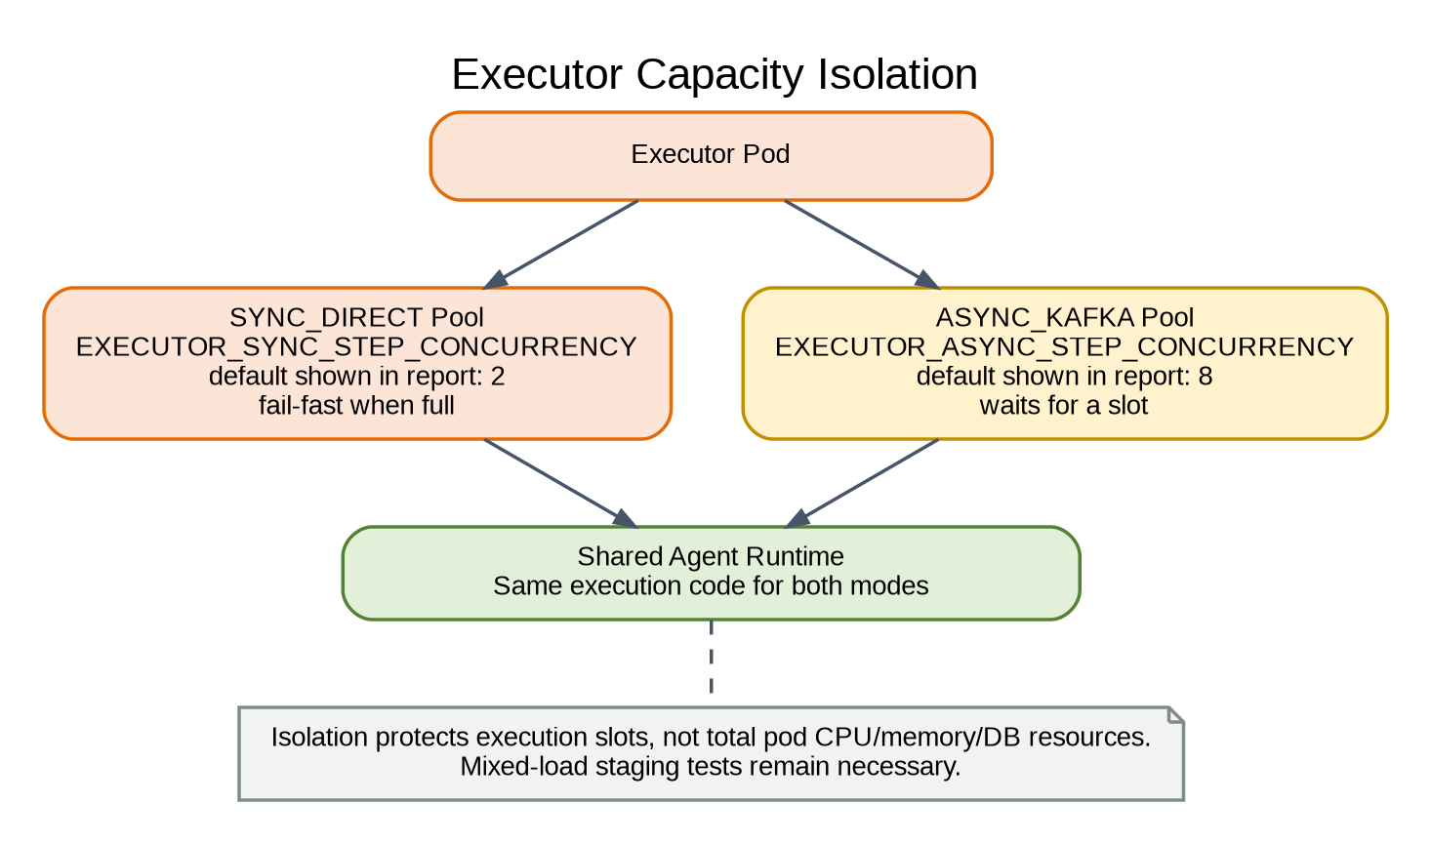
Figure 5 — Separate Executor semaphores protect execution slots for each mode.
Pool | Environment variable | Behavior reported
Sync | EXECUTOR_SYNC_STEP_CONCURRENCY | Independent semaphore; non-blocking/fail-fast acquisition. Report shows default 2.
Async | EXECUTOR_ASYNC_STEP_CONCURRENCY | Independent semaphore; waits for slot. Report shows default 8.

The report also notes that the semaphore values are read at process startup using environment access, so changing them requires a pod restart. Orchestration itself does not have a matching sync semaphore; its main concurrency control is the pooled HTTP client configuration.
Operational meaning
Separate semaphores prevent sync requests from consuming async execution slots. They do not create separate CPU, memory, database, or network resources; therefore mixed sync+async load testing is still required.

11. Internal Orchestration → Executor HTTP Communication
SyncStepClient maintains a shared, lazily created aiohttp.ClientSession backed by a TCP connection pool. One POST is made per agent step. The implementation described in the report has no automatic retry: a failed internal call surfaces to the coordinator.
Setting | Environment variable | Report value / behavior
Total connection pool | SYNC_HTTP_MAX_CONNECTIONS | 100
Per-host connection limit | SYNC_HTTP_MAX_CONNECTIONS_PER_HOST | 20
Executor base URL | SYNC_EXECUTOR_BASE_URL | Auto-derived cluster service DNS if unset
Step endpoint | SYNC_EXECUTOR_STEP_ENDPOINT | /internal/v1/agent-step
Internal credential | SYNC_EXECUTOR_API_KEY | Sent as X-Internal-Api-Key

- The shared client is closed on Orchestration application shutdown.
- The report states TLS certificate verification is disabled (ssl=False) for this cluster-local call.
- There is one HTTP round-trip per agent step, so multi-step latency includes multiple service-to-service calls.

12. Authentication and Security Boundary
Public sync APIs use the existing JWT mechanism. The private Executor step API uses a separate shared-secret header because it is service-to-service infrastructure, not a caller-facing endpoint.
Control | Implementation described in report
Public API auth | Standard COIN JWT / X-Authorization-Coin
Internal endpoint visibility | include_in_schema=False; hidden from Swagger
Internal header | X-Internal-Api-Key
Orchestration secret source | SYNC_EXECUTOR_API_KEY
Executor secret source | EXECUTOR_INTERNAL_STEP_API_KEY
Comparison | hmac.compare_digest constant-time comparison
Missing/mismatched secret | 403 with same external behavior; server unconfigured also rejects

Security consideration from the report
The /drain endpoint is not authenticated. The report treats this as acceptable only if the endpoint is reachable solely from the intended cluster/pod lifecycle path and is not externally exposed.

13. Timeout and Client Disconnect Handling
Control | Environment variable | Report default | Purpose
Overall sync deadline | SYNC_OVERALL_TIMEOUT_SECONDS | 120s | Absolute wall-clock budget for the entire sync request
Per-step timeout cap | SYNC_STEP_TIMEOUT_SECONDS | 45s | Maximum allowed time for one Executor round-trip
Safety margin | SYNC_TIMEOUT_SAFETY_MARGIN_SECONDS | 5s | Buffer subtracted when calculating remaining per-step budget

For each loop iteration, the coordinator uses the smaller of the configured step timeout and the remaining overall budget minus the safety margin. The Executor HTTP call is therefore bounded from Orchestration’s perspective.

13.1 Disconnect behavior
- request.is_disconnected() is checked before step dispatch.
- During a step, a disconnect polling coroutine races the Executor call using asyncio.wait(..., FIRST_COMPLETED).
- If the client disconnects first, the local in-flight HTTP task is cancelled/awaited and the coordinator terminates the workflow response path.
Executor-side gap identified by the report
There is no independent timeout/cancellation guard around the underlying Executor agent execution. If Orchestration times out or the caller disconnects after Executor has begun work, the LLM/tool execution can continue inside Executor even though Orchestration has abandoned the HTTP wait.

14. Graceful Drain and Readiness
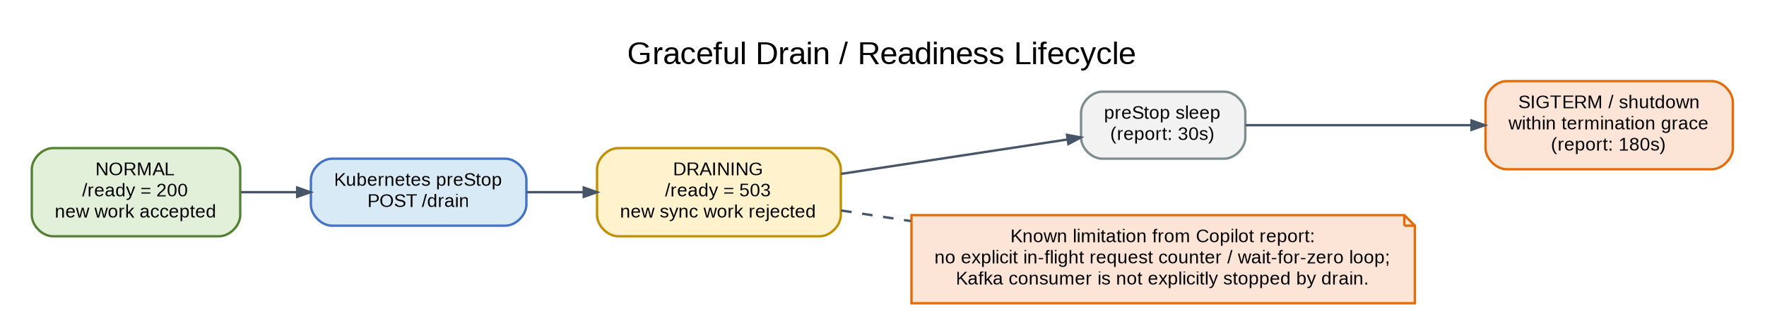
Figure 6 — Drain/readiness lifecycle implemented in both services.
Both services expose the same conceptual behavior: /ready returns healthy in normal operation and 503 after drain is triggered; /drain flips a process-local drain flag; new synchronous work is rejected while draining. Helm preStop calls /drain before the pod is terminated.
Known drain limitation from the report
Drain is a boolean flag plus a fixed preStop sleep. The report does not find an explicit in-flight request counter or a wait-until-zero mechanism, and it also notes that the Kafka consumer is not explicitly stopped by drain. A very long in-flight request can therefore still be terminated if it exceeds the available grace window.

15. Observability / Metrics
Both services expose Prometheus-format metrics at GET /metrics using prometheus-client, according to the report. Metrics were added to answer the main coexistence question: does synchronous load degrade the existing Kafka workload?
Service | Metric group | What it measures
Orchestration | orchestration_sync_request_duration_seconds | End-to-end sync request duration
Orchestration | orchestration_sync_timeout_total | Overall/step timeout events
Orchestration | orchestration_sync_client_disconnect_total | Client disconnects during sync execution
Orchestration | orchestration_sync_executor_http_failure_total | Internal Executor HTTP failures
Orchestration | orchestration_db_pool_* | DB pool size/checked-out/overflow/wait health
Orchestration | orchestration_kafka_consumer_lag | Existing async consumer lag
Executor | executor_active_steps{execution_mode} | In-flight work split by SYNC_DIRECT / ASYNC_KAFKA
Executor | executor_step_duration_seconds{execution_mode} | Step latency split by mode
Executor | executor_sync_rejected_total | Sync requests rejected when capacity is exhausted
Executor | executor_db_pool_* / executor_kafka_consumer_lag | DB and async Kafka health

Deployment note from the report
The Kubernetes deployment template shown by Copilot still has metrics.io/scrape_targets set to false. A platform-specific scrape configuration or ServiceMonitor update is therefore still required before the new /metrics endpoints are actually collected.

Test-coverage note from the report
The report states that metrics code is wired into request paths but unit tests do not assert that counters/gauges/histograms increment. Treat runtime scraping and mixed-load validation as separate readiness checks.

16. Helm / OpenShift / Configuration Changes
The report describes new optionA configuration in both charts, environment-variable injection in deployment templates, a preStop drain hook, and longer termination grace. Sync remains disabled by default until explicitly enabled per environment.
Service | Configuration family
Orchestration | SYNC_EXECUTION_ENABLED; SYNC_EXECUTOR_BASE_URL; SYNC_EXECUTOR_STEP_ENDPOINT; SYNC_EXECUTOR_API_KEY; overall/step/safety timeouts; HTTP pool limits
Executor | EXECUTOR_SYNC_DIRECT_STEP_API_ENABLED; EXECUTOR_INTERNAL_STEP_API_KEY; EXECUTOR_SYNC_STEP_CONCURRENCY; EXECUTOR_ASYNC_STEP_CONCURRENCY
Both | /ready and /drain lifecycle integration; preStop hook; terminationGracePeriodSeconds; metrics endpoint

- The report shows preStopSleepSeconds = 30s and terminationGracePeriodSeconds = 180s in the current Helm configuration.
- Environment-specific values do not override Option A enablement in the report; sync is therefore off by default until explicitly turned on.

17. Known Limitations and Validation Items
Item | Impact / action
Executor has no independent execution timeout | Orchestration can stop waiting, but already-running LLM/tool work may continue. Decide whether cooperative cancellation is required.
Drain lacks in-flight counter/wait-for-zero | A long request can still be killed after the grace window. Validate rolling restarts with real request durations.
Kafka consumer not explicitly stopped by drain | Validate async behavior during deployment/termination.
/drain unauthenticated | Keep it cluster-internal and ensure route/network policy prevents unwanted access.
Metrics scrape disabled in deployment annotation | Enable the platform’s Prometheus/ServiceMonitor scraping before relying on dashboards/alerts.
Metrics increments not unit-tested | Add focused tests or validate behavior in staging.
No internal HTTP retry | Transient internal call failures surface immediately; keep conservative behavior unless idempotency/retry semantics are designed.
Semaphore values are startup configuration | Concurrency tuning requires pod restart.

Scope discipline
These are findings explicitly visible in the supplied Copilot report. This rewritten document does not independently claim they are fixed or unfixed beyond that source.

18. Team Presentation Summary
A concise way to explain the completed architecture is:
One-sentence architecture
Orchestration now offers four blocking sync APIs that plan the workflow and drive each agent step over a protected internal HTTP endpoint, while Executor continues to run the same agent engine and preserves the existing Kafka async path behind an independent capacity pool.

18.1 Responsibility split
Component | Primary responsibility now
Caller | Chooses async delivery or a blocking sync endpoint.
Orchestration API | Authentication, validation, guardrails, planning and endpoint-specific request behavior.
SyncExecutionCoordinator | Owns synchronous sequencing, deadlines, disconnect handling and terminal finalization.
SyncStepClient | Provides pooled, authenticated internal HTTP transport to Executor.
Executor internal API | Accepts one already-planned step and selects SYNC_DIRECT mode.
ExecutionCapacityManager | Keeps sync and async execution slots independent.
Shared agent runtime | Runs agents, sessions, LLM/tool calls, audits and step-output conversion.
Finalization service | Builds consistent success/failure business responses for both transport modes.
Kafka / ResponseService | Remain the async transport/delivery path.

18.2 Readiness checklist
- Enable sync feature flags only in the intended environment.
- Provision matching internal API keys in Orchestration and Executor.
- Confirm cluster-local Executor service DNS and internal endpoint reachability.
- Enable Prometheus/ServiceMonitor scraping for /metrics.
- Run mixed async Kafka + sync HTTP load tests and verify async latency/Kafka lag stay within target.
- Exercise timeout, disconnect, capacity rejection and rolling-restart scenarios.
- Validate /drain is not externally reachable and confirm the chosen grace period is sufficient for real P99 sync latency.
- Tune sync/async semaphore limits and HTTP pool sizes using measured staging data rather than defaults.

